Experiment 2

Design a Logo using GIMP:-

Step 1:- Draw a Picture of Pikachu in a paper.

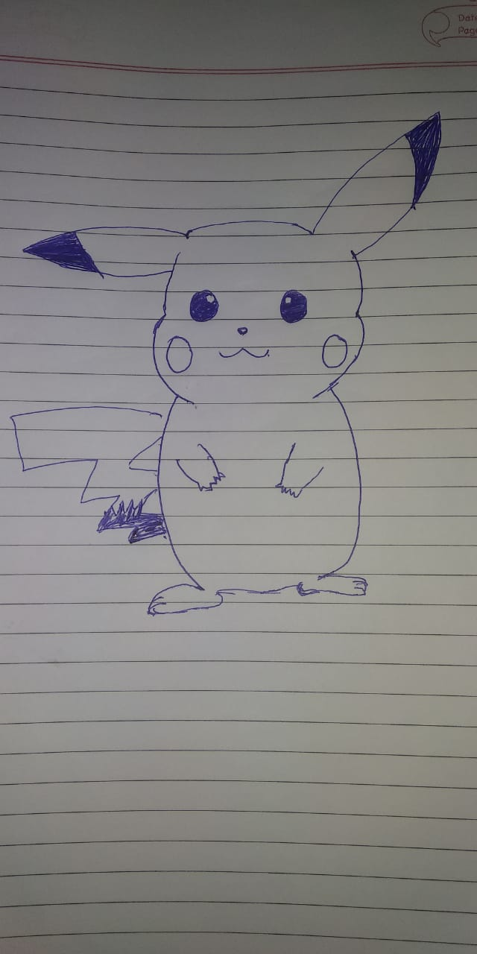

Step 2:- Open the GIMP and open the Pikachu image on the GIMP:-

Step 3:- use the magic sessions to cut-out the Pikachu outline.

Step 4:- Use bucket fill to add colors on the different parts of the Pikachu.

Step 5:- Open another layer in a square shape and add the horizontal guides and vertical guides on the layer.

Step 6:- Select the ellipse tool and create a circle in the layer by pressing ctrl+Z to set the circle in the centre.

Step 7:- Fill the circle with the black color.

Step 8:- Now again add another transparent layer and add a circle using same way but this time a little small then previous one.

Step 8:- Now select the inside part of the circle and delete the selected area.

Step 9:- Now delete the second layer .

Step 10:- Now add another transparent layer and create a rectangle using ctrl+Z smaller then circle but coners of the square should be came out from the circle . fill it with black circle

Step 11:- Again add a transparent layer and create the same square but little smaller then the previous one. Color the square and select the middle part and delete it.Delete the layer too.

Step 12:- Now rotate the square . After rotating the square use eraser to erase the those section of circle and rectangle which are touching each other.

Step 13:- Now open the saved Pikachu image which was edited first as a new layer.

Step 14:- Adjust the image of Pikachu inside the design and you get the logo like as follows:-

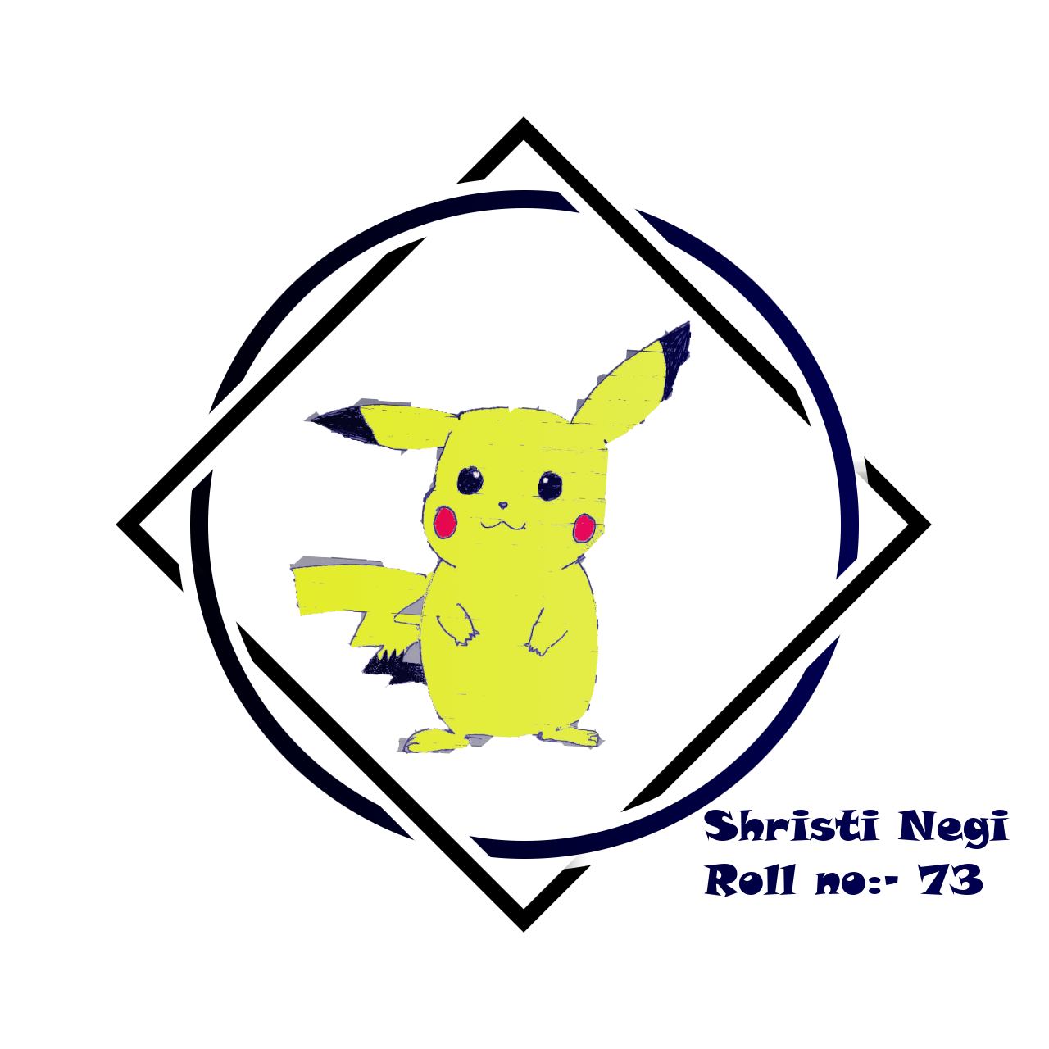

This is the final logo.